Rule for Enforcement of Declaration of Covenants, Conditions, Restrictions and Lien for Hawk Ridge
WHEREAS Article III Enforcement, paragraph 5.2 Purpose of ARC and paragraph 5.7 Guidelines, Standards and Procedures of the Declaration of Covenants, Conditions, Restrictions and Lien for Hawk Ridge (CC&R), dated 19 July 1994, provide that the Association may adopt and publish rules and Guidelines with which each Hawk Ridge property owner and other occupants shall strictly comply:
NOW, THEREFORE, BE IT RESOLVED that the following are adopted by the Board of Directors of Hawk Ridge Homeowners Association as the Rule for Enforcement of Declaration of Covenants, Conditions, Restrictions and Lien for Hawk Ridge:
- BASIC PHILOSOPHY

- The purpose of the Covenants is to evaluate the effect of any improvements on surrounding lots and adjacent or neighboring properties, to maintain the harmony with the surroundings, and to maintain the superior beauty and quality of any improvements.
- The restrictions contained in the Covenants are designed to be mutually beneficial for declarant (Association), as well as current and future owners.
- The ARC is not a police force and, while it will attempt to resolve homeowner violations that are brought to its attention, it will not actively “patrol” the neighborhood in search of covenant violations.
- The objective is to resolve all potential violations at the lowest possible level, while maintaining neighborly interactions between the Association and its homeowners.
- Only violations/issues that are explicitly stated in the CC&R (i.e. para x.x) will be considered by the ARC. Violations/issues that do not meet this standard will be forwarded to the HOA Board for their review/action.
- For purposes of clarity, the words “violation”, “discrepancy”, and “issue” have the same meaning in the following paragraphs.

- PROCESS

- Potential violations can be identified by an Association officer*, ARC member*, or individual homeowner. The person noting the violation should call the homeowner and attempt to have the discrepancy corrected without further action. If an individual homeowner was the one who noted the discrepancy and is not comfortable discussing the issue with the violator, they should notify an ARC member for further action. If an Association officer was the one noting the discrepancy, they should notify an ARC member before making the phone call. This will ensure that the ARC is aware of all potential violations.
- If the discrepancy can be corrected with a phone call, no further action is required. If not, the person noting the violation should document the circumstances in an email or letter to the ARC, outlining the nature of the violation, specific circumstances, and action taken to date.
- The violation will be verified by a member of the ARC (see A.5 above). The ARC member should call the violator and ask if they would like to file an appeal with the ARC. An appeal can be made by the homeowner to the ARC in writing and it should include all pertinent information related to the violation in question.
- The situation will be discussed among the ARC members. Upon review and discussion, the ARC members will vote**:

  - If the ARC votes not to pursue enforcement, they will document their decision and inform the homeowner and the person who originally noted the discrepancy.

  - If the ARC votes to pursue and/or the appeal denied, their decision will be documented and forwarded to Board members for consideration and further action
- Board Directors will vote on whether to pursue enforcement action, with consideration given to:
  - Egregious nature of the violation and consequences for continued non-compliance
  - Past precedents with respect to the same violation
  - Any past violations by the offending homeowner
  - Special circumstances that should be considered, if any

    - If Board members vote not to pursue enforcement, the homeowner should be notified by an Officer that the Association will take no further action. In addition, the person reporting the violation should be notified by an Officer, explaining the Board’s rationale for non-action.

    - If Board members vote to pursue enforcement, the following actions will be taken:
      - A phone call from the ARC notifying the homeowner that the Board has considered the appeal (if applicable) and has voted to pursue enforcement. The homeowner should be informed that if corrective action is taken by a specified date, no further action will be taken. The date should be negotiated between the ARC and the homeowner.
      - If corrective action is not taken by the date specified, a letter signed by the Board President will be sent, informing the homeowner that they are in violation of the Covenants (to include the specific provision), details on the specific violation, a due date for corrective action, and consequence for continued non-compliance (fine, lien)***.
      - If the corrective action isn’t taken by the due date, a fine will be assessed as outlined in the letter to the homeowner.

* If the homeowner accused of the violation is a current member of the HOA Board or ARC they will recuse themselves from any proceedings related to the processing of the violation. They may, however, appeal the issue just like any other homeowner.
** All Vote decisions will be based on simple majority of voting members
*** Fines will be assessed at a rate of up to $ 100/day until corrective action is completed. After 30 days, if corrective action is not taken, a lien will be placed on the offending homeowner’s property
Adopted by the Hawk Ridge Homeowners Association Board of Directors this 8th day of September, 2021.
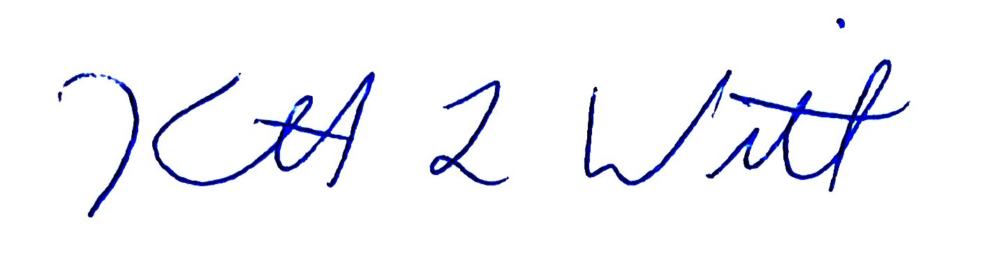
___________________________________
President

